

VOLUNTARY NON-REMUNERATED BLOOD DONATION

Software Requirement Specification

Project Code: VNBD

Document Code: VNBD_Software Requirements Specification_v1.0

**Ha Noi, 20/09/2013**

Record of change

*A - Added M - Modified D - Deleted

|  |  |  |  |  |
| --- | --- | --- | --- | --- |
| Effective Date | Changed Items | A* M, D | Change Description | New Version |
| 20/09/2013 | Add new | A |  | v0.9 |
| 30/09/2013 | Change 3.1. Functionality. | M | Update functionality follow comments of supervisor. | v0.9.1 |
| 02/10/2013 | Change 3.1. Functionality. | M | Update functionality follow comments of supervisor. | v1.0 |
|  |  |  |  |  |
|  |  |  |  |  |
|  |  |  |  |  |
|  |  |  |  |  |
|  |  |  |  |  |
|  |  |  |  |  |
|  |  |  |  |  |
|  |  |  |  |  |
|  |  |  |  |  |
|  |  |  |  |  |
|  |  |  |  |  |
|  |  |  |  |  |
|  |  |  |  |  |
|  |  |  |  |  |
|  |  |  |  |  |
|  |  |  |  |  |
|  |  |  |  |  |
|  |  |  |  |  |

SIGNATURE PAGE

**ORIGINATOR:** Ngo Tran Linh 20/09/2013

Project Manager

**REVIEWERS:** Ngo Tran Linh 02/10/2013

Project Manager

**APPROVAL:** Bui Dinh Chien 02/10/2013

Supervisor

TABLE OF CONTENTS

1 Introduction 6

1.1 Purpose 6

1.2 Scope 6

1.3 Definitions, Acronyms, and Abbreviations 6

1.4 References 6

1.5 Overview 6

2 Overall Description 8

3 Specific Requirements 15

3.1 3.1 Functionality 15

3.1.1 Register 15

3.1.2 View Public Information 18

3.1.3 Login 19

3.1.4 Reset Password 21

3.1.5 Logout 22

3.1.6 Edit Profile user 24

3.1.7 Comment 27

3.1.8 View Posts 28

3.1.9 Register Donating Blood 30

3.1.10 Create Q&A 32

3.1.11 Delete Q&A 34

3.1.12 Edit Q&A 35

3.1.13 Search Text 36

3.1.14 Advanced Search 37

3.1.15 Register Receiving Blood 38

3.1.16 Create Post 40

3.1.17 Edit Post 41

3.1.18 Delete Post 43

3.1.19 Contact Us 44

3.1.20 View Registered User List 47

3.1.21 Delete User 48

3.1.22 Ban User 49

3.1.23 Unban User 50

3.1.24 Delete User 51

3.1.25 View Post 52

3.1.26 Create Post 53

3.1.27 Edit Post 54

3.1.28 View Comment List 56

3.1.29 Delete Comment 57

3.1.30 View Q&A List 58

3.1.31 Delete Q&A 59

3.1.32 View History Donating Blood 60

3.1.33 View History Receiving Blood 61

3.1.34 Count Actions Donating Blood 62

3.1.35 Count Actions Receiving Blood 63

3.2 Usability 64

3.3 Reliability 64

3.4 Performance 64

3.5 Supportability 64

3.6 Design Constraints 64

3.7 On-line User Documentation and Help System Requirements 64

3.8 Purchased Components 65

3.9 Interfaces 65

3.10 Licensing Requirements 65

3.11 Legal, Copyright, and Other Notices 65

3.12 Applicable Standards 65

4 Supporting Information 66

# Introduction

## Purpose

This project is registered and implemented as a capstone project for the team members. Our purpose is to fulfill the requirements from FPT University studying program. In addition, we aim to create a website which orients the object – Volunteer who want to donate their blood for other people and People who need donated blood because they can’t pay for hospital's blood. This website as a bridge to connect them, we guarantee volunteer’s blood will help accurate people. One more thing, this website has a forum to provide important information about: sexual, blood type, advantages and disadvantages when you donate blood.

## Scope

The scope of this project contains: Requirement Analysis, Design, Coding and Testing.

## Definitions, Acronyms, and Abbreviations

Table1. Definitions, Acronyms

| Acronym | Definition | Note |
| --- | --- | --- |
| VNBD | Voluntary non-remunerated blood donation |  |

## References

Table2. References

|  |  |  |  |  |
| --- | --- | --- | --- | --- |
| No | Reference item | Issued Date | Source | Note |
| 1 | VNBD_ Project Plan_v1.0_EN.docx | 20/09/2013 | Report 1 for supervisor or SVN of project |  |

## Overview

The rest of the SRS document contains the detail description the requirement of Voluntary non-remunerated blood donation website and the information that helps to read it easily. There are three parts:

* Part 1. Overall description: This section describes the general factors that affect the product and its requirements.
* Part 2. Specific requirements: This section contains all software requirements to a level of detail sufficient to enable designers to design a system to satisfy those requirements, and testers to test that the system satisfies those requirements.
* Part 3. Supporting information: The supporting information makes the SRS easier to use.

# Overall Description

* Product perspectives:
* Nowadays, there are a lot of poor patients must be pay lots of money to receive blood when they are in case of emergency. However, there are so many volunteer are donating blood each day. Because of this, we would create this website as a bridge to bring volunteer’s blood for exactly poor patient. Besides it, the website and blood is no fee, it is easy to get support from admin via website or hot line of website.
* User characteristics:

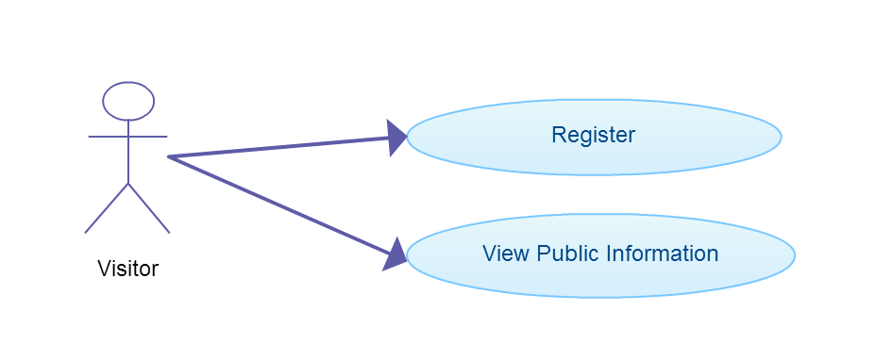

Visitor use-case

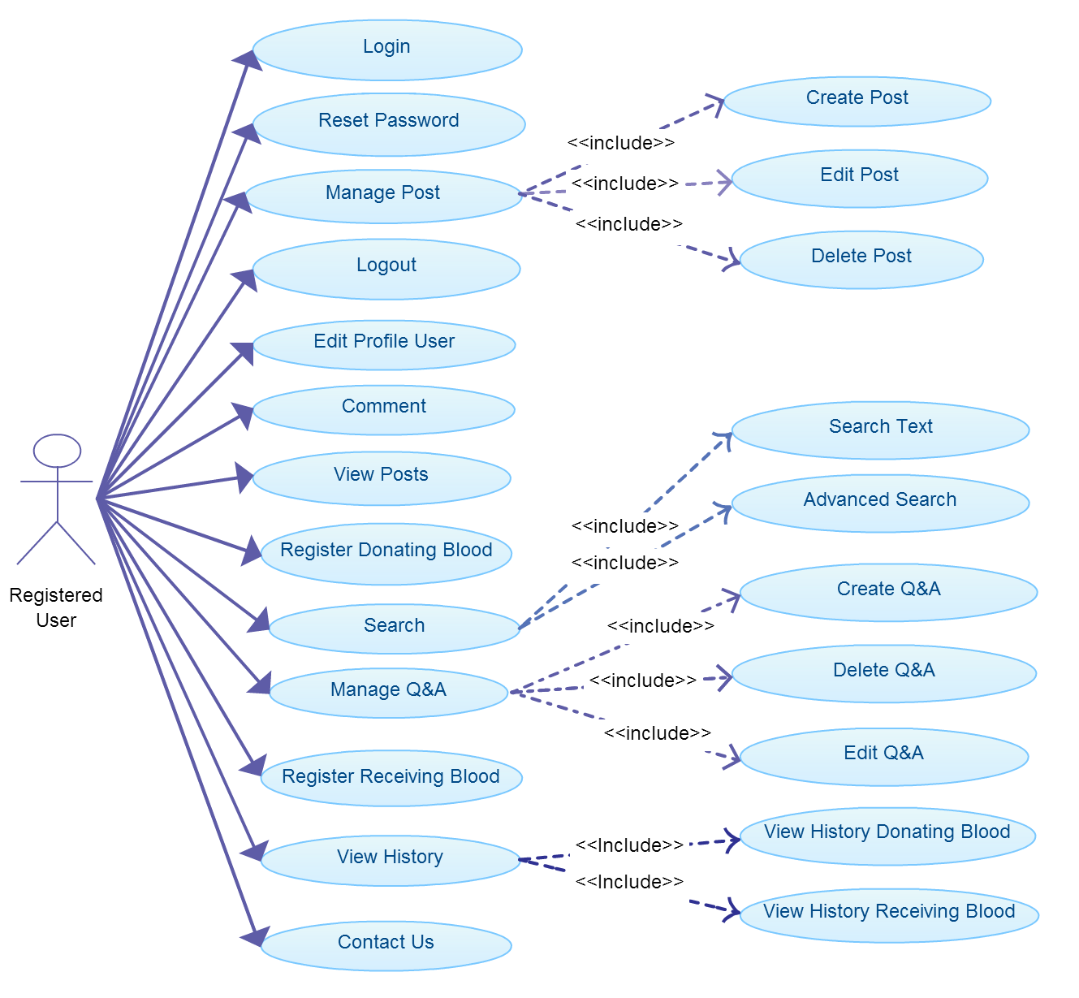

Registered user use-case

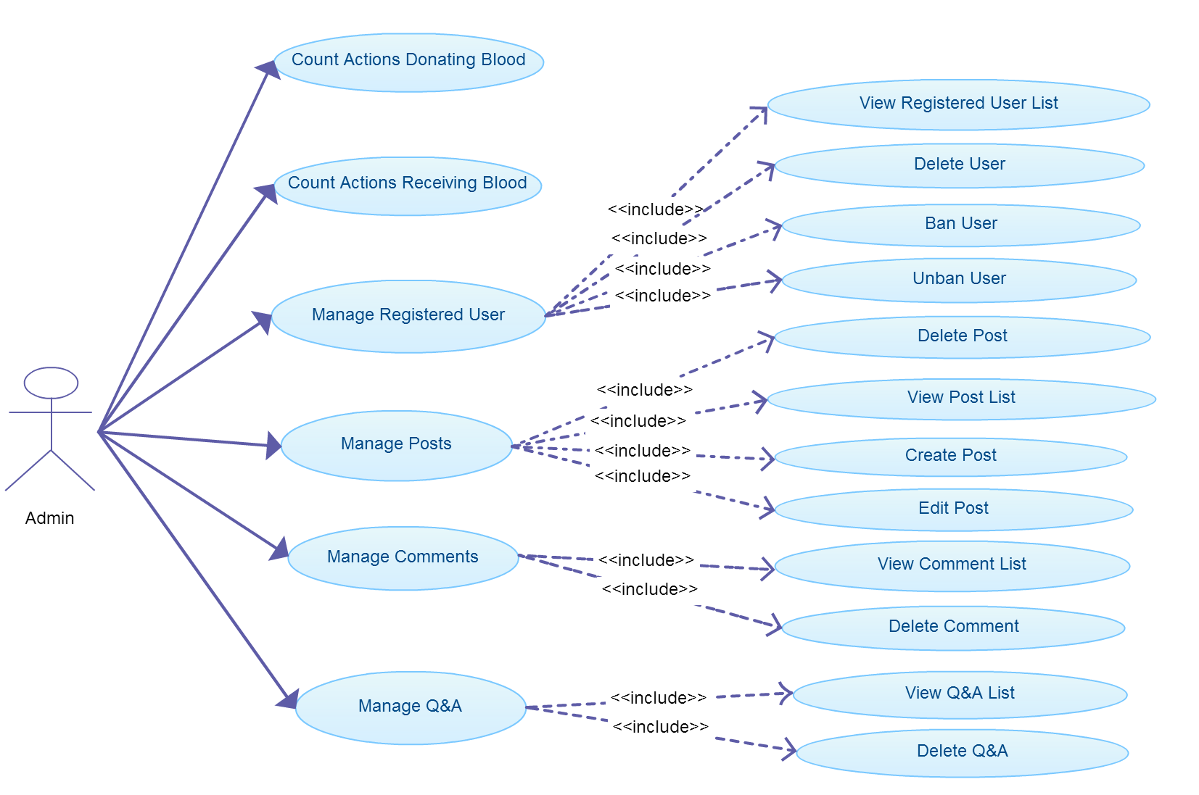

Admin use-case

* Product functions:

|  |  |  |  |
| --- | --- | --- | --- |
| ID | Name | Use case ID | Page |
| 1 | Register | UC001 | 14 |
| 2 | View Public Information | UC002 | 17 |
| 3 | Login | UC003 | 18 |
| 4 | Reset Password | UC004 | 20 |
| 5 | Logout | UC005 | 21 |
| 6 | Edit Profile User | UC006 | 23 |
| 7 | Comment | UC007 | 26 |
| 8 | View Posts | UC008 | 27 |
| 9 | Register Donating Blood | UC009 | 29 |
| 10 | Manage Q&A: Create Q&A | UC011 | 31 |
| 11 | Manage Q&A: Delete Q&A | UC011 | 33 |
| 12 | Manage Q&A: Edit Q&A | UC012 | 34 |
| 13 | Search: Search Text | UC013 | 35 |
| 14 | Search: Search Advanced | UC014 | 36 |
| 15 | Register Receiving Blood | UC015 | 37 |
| 16 | Manage Post: Create Post | UC016 | 39 |
| 17 | Manage Post: Edit Post | UC017 | 40 |
| 18 | Manage Post: Delete Post | UC018 | 42 |
| 19 | Contact Us | UC019 | 43 |
| 20 | Manage Registered User: View Registered User List | UC020 | 46 |
| 21 | Manage Registered User: Delete User | UC021 | 47 |
| 22 | Manage Registered User: Ban User | UC022 | 48 |
| 23 | Manage Registered User: Unban User | UC023 | 49 |
| 24 | Manage Posts: Delete Post | UC024 | 50 |
| 25 | Manage Posts: View Post | UC025 | 51 |
| 26 | Manage Posts: Create Post | UC026 | 52 |
| 27 | Manage Posts: Edit Post | UC027 | 53 |
| 28 | Manage Comments: View Comment List | UC028 | 55 |
| 29 | Manage Comments: Delete Comment | UC029 | 56 |
| 30 | Manage Q&A: View Q&A List | UC030 | 57 |
| 31 | Manage Q&A: Delete Q&A List | UC031 | 58 |
| 32 | View History Donating Blood | UC032 | 60 |
| 33 | View History Receiving Blood | UC033 | 61 |
| 34 | Count Actions Donating Blood | UC034 | 62 |
| 35 | Count Actions Receiving Blood | UC035 | 63 |

* Constraints:
* Resource constraints:
* There are five people in this project and it is a constant. Team members never change during the project performance.
* Quality constraints:
* Target of metrics must be satisfied.
* All bugs are closed before delivering.
* Progress Report, Q&A, Installation Guide must be completed by Japanese.
* Time and Date constraints:
* Follow this table:

Table3. Time and Date constraints

| No | Description | Note |
| --- | --- | --- |
| Assumptions | | |
| 1 | Report No 1 must be completed and delivered to teacher after week 2. | Schedule |
| 2 | Report No 2 must be completed and delivered to teacher after week 4. | Schedule |
| 3 | Report No 3 must be completed and delivered to teacher after week 6. | Schedule |
| 4 | Report No 4 must be completed and delivered to teacher after week 10. | Schedule |
| 5 | Report No 5 must be completed and delivered to teacher after week 12. | Schedule |
| 6 | Report No 6 must be completed and delivered to teacher after week 14. | Schedule |

# Specific Requirements

## 3.1 Functionality

## Register

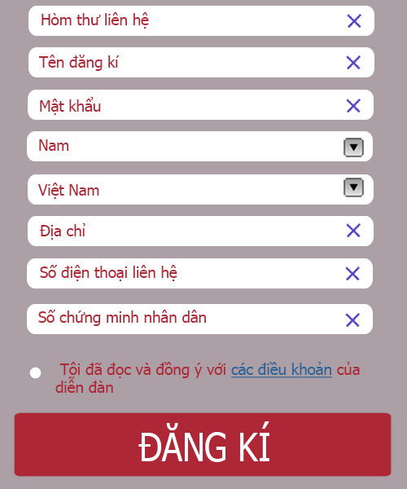

Figure1: Đăng kí

|  |  |
| --- | --- |
| Register | |
| Use case ID | UC001 |
| Use case Name | Register |
| Primary Actor | Visitor |
| Description | Visitor can create new account to use more functions as a registered user. |
| Goal | Registered new account for visitor. |
| Actions | User click on “Đăng kí” link in login form. |
| Preconditions | Going to the website |
| Main success scenario | |  |  |  | | --- | --- | --- | |  | Actor Input | System Response | | 1 | Click on "Đăng kí" link. |  | | 2 |  | Display form register. | | 3 | Enter necessary and mandatory information and click "Đăng kí" button. |  | | 4 |  | Redirect to previous page and logged user into system. | |
| Post-conditions | Redirect user to previous page. |
| Exceptions | |  |  |  | | --- | --- | --- | |  | Actor Input | System Response | |  | Click on “Đăng kí" link. |  | |  |  | Display form register. | |  | Missing “Hòm thư liên hệ” field and click “Đăng kí” button |  | |  |  | Display error message beside“Hòm thư liên hệ” field. | |  | Missing “Tên đăng ký” field and click “Đăng kí” button |  | |  |  | Display error message beside “Tên đăng ký” field. | |  | Enter incorrect information or missing “Mật khẩu” field and click “Đăng kí” button |  | |  |  | Display error message beside “Mật khẩu” field. | |  | Enter incorrect information or missing “Địa chỉ” field and click “Đăng kí” button |  | |  |  | Display error message beside “Địa chỉ” field. | |  | Enter incorrect information or missing “Số điện thoại liên hệ” field and click “Đăng kí” button |  | |  |  | Display error message beside “Số điện thoại liên hệ” field. | |  | Enter incorrect information or missing “Số chứng minh nhân dân” field and click “Đăng kí” button |  | |  |  | Display error message beside “Số chứng minh nhân dân” field. | |  | Don’t click on radio button confirm |  | |  |  | Display error message in front of radio button. | |
| Author | TamNT01730 |
| Date | 10/02/2013 |

## View Public Information

|  |  |
| --- | --- |
| View Public Information | |
| Use case ID | UC002 |
| Use case Name | View Public Information |
| Primary Actor | Visitor, Registered User, Admin |
| Description | All users can view public information in the website. |
| Goal | View information |
| Actions | Going to the website |
| Preconditions | None |
| Main success scenario | |  |  |  | | --- | --- | --- | |  | Actor Input | System Response | | 1 | Going to the website |  | | 2 |  | Display website. | |
| Post-conditions | None |
| Exceptions | |  |  |  | | --- | --- | --- | |  | Actor Input | System Response | |  |  |  | |  |  |  | |
| Author | TamNT01730 |
| Date | 10/02/2013 |

## Login

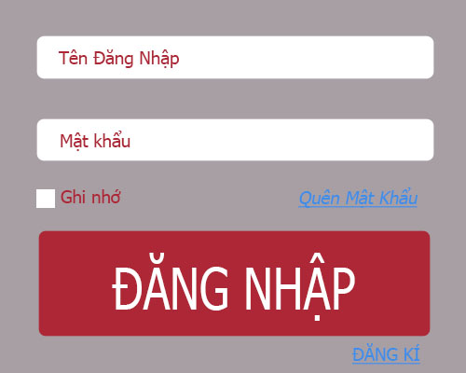

Figure2: Đăng nhập

|  |  |
| --- | --- |
| Login | |
| Use case ID | UC003 |
| Use case Name | Login |
| Primary Actor | Registered User, Admin |
| Description | When user wants to login into system to use advance functions. |
| Goal | User logged into system successfully. |
| Actions | User clicks on "Đăng nhập" link. |
| Preconditions | User had registered account information. |
| Main success scenario | |  |  |  | | --- | --- | --- | |  | Actor Input | System Response | | 1 | Click on "Đăng nhập" link. |  | | 2 |  | Display login page | | 3 | Enter necessary and mandatory information and click "Đăng nhập" button. |  | | 4 |  | Validate information and log user into system. | |
| Post-conditions | Redirect user to previous page. |
| Exceptions | |  |  |  | | --- | --- | --- | |  | Actor Input | System Response | |  | Click on "Đăng nhập" link. |  | |  |  | Display login page | |  | Enter incorrect or missing information “Tên đăng nhập” field |  | |  |  | Display error message beside “Tên đăng nhập” field. | |  | Enter incorrect or missing information “Mật khẩu” field |  | |  |  | Display error message beside “Mật khẩu” field. | |
| Author | TamNT01730 |
| Date | 10/02/2013 |

## Reset Password

|  |  |
| --- | --- |
| Reset Password | |
| Use case ID | UC004 |
| Use case Name | Reset Password |
| Primary Actor | Registered User |
| Description | When user forgot your password to login into system to use advance functions. |
| Goal | Receiving new password |
| Actions | User clicks on "Đăng nhập" link. |
| Preconditions | User had registered account information. |
| Main success scenario | |  |  |  | | --- | --- | --- | |  | Actor Input | System Response | | 1 | Click on "Đăng nhập" link. |  | | 2 |  | Display login page | | 3 | Click on "Quên mật khẩu" link. |  | | 4 |  | Admin will send new password into your email. | |
| Post-conditions | Redirect user to previous page. |
| Exceptions | |  |  |  | | --- | --- | --- | |  | Actor Input | System Response | |  |  |  | |  |  |  | |
| Author | TamNT01730 |
| Date | 10/02/2013 |

## Logout

|  |  |
| --- | --- |
| Logout | |
| Use case ID | UC005 |
| Use case Name | Logout |
| Primary Actor | Registered User, Admin |
| Description | When user wants to logout their account |
| Goal | Logout the website |
| Actions | User clicks on "Đăng xuất" link. |
| Preconditions | User logged into the website |
| Main success scenario | |  |  |  | | --- | --- | --- | |  | Actor Input | System Response | | 1 | Click on "Đăng nhập" link. |  | | 2 |  | Display login page | | 3 | Click on "Đăng xuất" link. |  | | 4 |  | Logout the website | |
| Post-conditions | Display “Đăng nhập” form |
| Exceptions | |  |  |  | | --- | --- | --- | |  | Actor Input | System Response | |  |  |  | |  |  |  | |
| Author | TamNT01730 |
| Date | 10/02/2013 |

## Edit Profile user

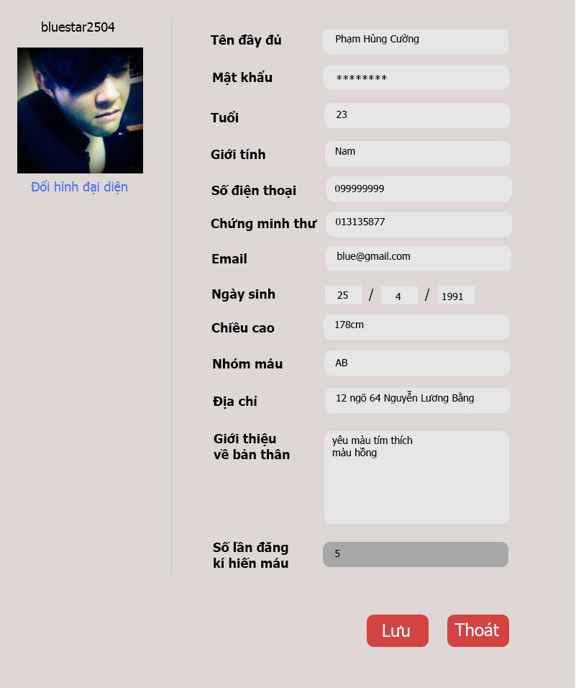

Figure3: Sửa đổi thông tin cá nhân

|  |  |
| --- | --- |
| Edit Profile User | |
| Use case ID | UC006 |
| Use case Name | Edit Profile User |
| Primary Actor | Registered User, Admin |
| Description | When user wants to change their profile |
| Goal | Change profile successful |
| Actions | User clicks on "Trang cá nhân" link. |
| Preconditions | User login into the website |
| Main success scenario | |  |  |  | | --- | --- | --- | |  | Actor Input | System Response | |  | Click on "Đăng nhập" link. |  | |  |  | Display login page | |  | Click on "Trang cá nhân" link. |  | |  |  | Display “Trang cá nhân” page | |  | User changes profile and click “Lưu” button |  | |  |  | Update new profile | |
| Post-conditions | Display “Trang cá nhân" page with new image. |
| Exceptions | |  |  |  | | --- | --- | --- | |  | Actor Input | System Response | |  | Click "Đăng nhập" link. |  | |  |  | Display login page | |  | Click "Trang cá nhân" link. |  | |  |  | Display “Trang cá nhân” page | |  | Click “Sửa ảnh đại diện” link |  | |  |  | Display form to select address that has picture. | |  | User select one picture that image size too heavy and click “Lưu” button |  | |  |  | Display error message. | |  | Enter new identification number that incorrect form or missing information and click “Lưu” button |  | |  |  | Display error message. | |  | Enter new password that incorrect form or missing information and click “Lưu” button |  | |  |  | Display error message. | |  | Enter new email that incorrect form or missing information and click “Lưu” button |  | |  |  | Display error message. | |  | Missing information and click “Lưu” button |  | |  |  | Display error message. | |  | Missing information and click “Lưu” button |  | |  |  | Display error message. | |
| Author | TamNT01730 |
| Date | 10/02/2013 |

## Comment

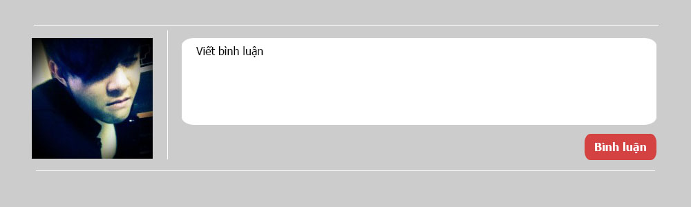

Figure4: Bình luận

|  |  |
| --- | --- |
| Comment | |
| Use case ID | UC007 |
| Use case Name | Comment |
| Primary Actor | Registered User, Admin |
| Description | When user wants to comment for news, pictures in the website |
| Goal | Comment successfully |
| Actions | User input their opinion in under form |
| Preconditions | User login into the website |
| Main success scenario | |  |  |  | | --- | --- | --- | |  | Actor Input | System Response | | 1 | Click on "Đăng nhập" link. |  | | 2 |  | Display login page | | 3 | Open post that you want to comment, enter information and click“Gửi” button |  | | 4 |  | Add new comment under post. | |
| Post-conditions | Display page that has new comment of user |
| Exceptions | |  |  |  | | --- | --- | --- | |  | Actor Input | System Response | | 1 | Click on "Đăng nhập" link. |  | | 2 |  | Display login page | | 3 | Open post that you want to comment, enter text is too long or missing information and click“Gửi” button |  | | 4 |  | Display error message | |
| Author | TamNT01730 |
| Date | 10/02/2013 |

## View Posts

|  |  |
| --- | --- |
| View Posts | |
| Use case ID | UC008 |
| Use case Name | View Posts |
| Primary Actor | Registered User, Admin |
| Description | Registered User/ Admin can view all posts in the website. |
| Goal | View posts |
| Actions |  |
| Preconditions | User login into the website |
| Main success scenario | |  |  |  | | --- | --- | --- | |  | Actor Input | System Response | | 1 | Click on "Đăng nhập" link. |  | | 2 |  | Display login page | |
| Post-conditions |  |
| Exceptions | |  |  |  | | --- | --- | --- | |  | Actor Input | System Response | |  |  |  | |  |  |  | |
| Author | TamNT01730 |
| Date | 10/02/2013 |

## Register Donating Blood

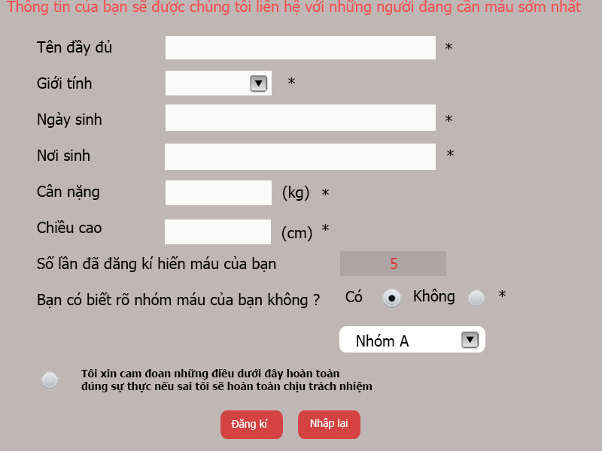

Figure5: Đăng ký hiến

|  |  |
| --- | --- |
| Register Donating Blood | |
| Use case ID | UC009 |
| Use case Name | Register Donating Blood |
| Primary Actor | Registered User, Admin |
| Description | Registered User/ admin can register donating blood in the website. |
| Goal | Register donating blood successful |
| Actions |  |
| Preconditions | User login into the website |
| Main success scenario | |  |  |  | | --- | --- | --- | |  | Actor Input | System Response | | 1 | Click on “Đăng nhập” link. |  | | 2 |  | Display login page | | 3 | Click on “Đăng ký hiến máu” |  | | 4 |  | Display “Đăng ký hiến máu” page | | 5 | Enter necessary and mandatory information and click "Đăng ký" button. |  | | 6 |  | Display message confirm successful. | |
| Post-conditions |  |
| Exceptions | |  |  |  | | --- | --- | --- | |  | Actor Input | System Response | | 1 | Click on “Đăng nhập” link. |  | | 2 |  | Display login page | | 3 | Click on “Đăng ký hiến máu” |  | | 4 |  | Display “Đăng ký hiến máu” page | | 5 | Enter information incorrect or missing mandatory fields & click “Đăng ký” button. |  | | 6 |  | Display error message beside wrong fields. | |
| Author | TamNT01730 |
| Date | 10/02/2013 |

## Create Q&A

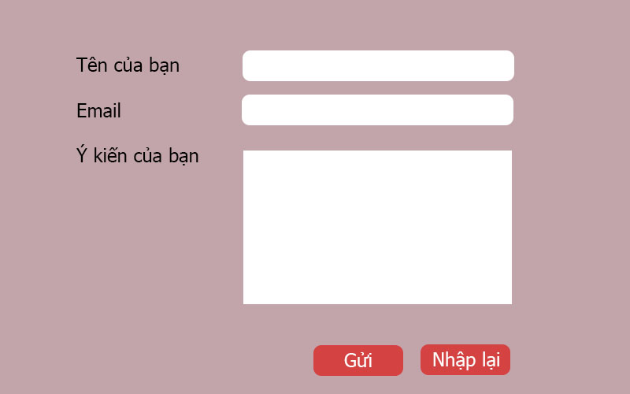

Figure6: Tạo Q&A

|  |  |
| --- | --- |
| Manage Q&A: Create Q&A | |
| Use case ID | UC010 |
| Use case Name | Manage Q&A: Create Q&A |
| Primary Actor | Registered User, Admin |
| Description | Registered User/ admin can create Q&A in the website. |
| Goal | Information exchange |
| Actions | Create Q&A successful |
| Preconditions | User login into the website |
| Main success scenario | |  |  |  | | --- | --- | --- | |  | Actor Input | System Response | | 1 | Click on “Đăng nhập” link. |  | | 2 |  | Display login page | | 3 | Click on “Hỏi đáp” section |  | | 4 |  | Display “Hỏi đáp” page | | 5 | Enter necessary and mandatory information in the “Hỏi đáp” form and click "Gửi" button. |  | | 6 |  | Display this Q&A in the “Hỏi đáp”section. | |
| Post-conditions | Add new Q&A into the website |
| Exceptions | |  |  |  | | --- | --- | --- | |  | Actor Input | System Response | | 1 | Click on “Đăng nhập” link. |  | | 2 |  | Display login page | | 3 | Click on “Hỏi đáp” section |  | | 4 |  | Display “Hỏi đáp” page | | 5 | Enter information incorrect or missing mandatory fields in the “Hỏi đáp”& click “Gửi” button. |  | | 6 |  | Display error message beside wrong fields. | |
| Author | TamNT01730 |
| Date | 10/02/2013 |

## Delete Q&A

|  |  |
| --- | --- |
| Manage Q&A: Delete Q&A | |
| Use case ID | UC011 |
| Use case Name | Manage Q&A: Delete Q&A |
| Primary Actor | Registered User, Admin |
| Description | Registered User/ admin can delete Q&A that they posted in the website. |
| Goal | Delete Q&A successful |
| Actions | Delete Q&A |
| Preconditions | User login into the website |
| Main success scenario | |  |  |  | | --- | --- | --- | |  | Actor Input | System Response | | 1 | Click on “Đăng nhập” link. |  | | 2 |  | Display login page | | 3 | Click on “Hỏi đáp” section |  | | 4 |  | Display “Hỏi đáp” page | | 5 | Select “X” in the corner of Q&A |  | | 6 |  | Delete that Q&A | |
| Post-conditions | Delete Q&A in the website |
| Exceptions | |  |  |  | | --- | --- | --- | |  | Actor Input | System Response | |  |  |  | |  |  |  | |
| Author | TamNT01730 |
| Date | 10/02/2013 |

## Edit Q&A

|  |  |
| --- | --- |
| Manage Q&A: Edit Q&A | |
| Use case ID | UC012 |
| Use case Name | Manage Q&A: Edit Q&A |
| Primary Actor | Registered User |
| Description | Registered User/ admin can edit Q&A that they posted in the website when nobody has posted a comment to that Q&A. |
| Goal | Edit Q&A successful |
| Actions | Edit Q&A |
| Preconditions | User login into the website |
| Main success scenario | |  |  |  | | --- | --- | --- | |  | Actor Input | System Response | | 1 | Click on “Đăng nhập” link. |  | | 2 |  | Display login page | | 3 | Click on “Hỏi đáp” section |  | | 4 |  | Display “Hỏi đáp” page | | 5 | Select “Edit” button of Q&A that you want to edit and update information. |  | | 6 |  | Update that Q&A | |
| Post-conditions | Update Q&A in the website |
| Exceptions | |  |  |  | | --- | --- | --- | |  | Actor Input | System Response | |  |  |  | |  |  |  | |
| Author | TamNT01730 |
| Date | 10/02/2013 |

## Search Text

|  |  |
| --- | --- |
| Search Text | |
| Use case ID | UC013 |
| Use case Name | Search Text |
| Primary Actor | Visitor, Registered User, Admin |
| Description | Visitor, Registered User/ admin can search text that displayed in the website. |
| Goal | Find text |
| Actions | Search text |
| Preconditions |  |
| Main success scenario | |  |  |  | | --- | --- | --- | |  | Actor Input | System Response | | 1 | Enter text that you want to search and click symbol search |  | | 2 |  | Display all information that contains key word of user. | |
| Post-conditions |  |
| Exceptions | |  |  |  | | --- | --- | --- | |  | Actor Input | System Response | |  |  |  | |  |  |  | |
| Author | TamNT01730 |
| Date | 10/02/2013 |

## Advanced Search

|  |  |
| --- | --- |
| Search: Advanced Search | |
| Use case ID | UC014 |
| Use case Name | Search: Advanced Search |
| Primary Actor | Registered User, Admin |
| Description | Visitor, Registered User/ admin can search blood type, by Status, by Gender of register donating/ receiving blood |
| Goal | Find blood type successful |
| Actions | Search blood type |
| Preconditions |  |
| Main success scenario | |  |  |  | | --- | --- | --- | |  | Actor Input | System Response | | 1 | Click on “Đăng nhập” link. |  | | 2 |  | Display login page | | 3 | Click on “Kho máu” section |  | | 4 |  | Display “Kho máu” page | | 5 | Click on “Tìm kiếm” link and select blood type or select status or select gender, click “Tìm kiếm” button |  | | 5 |  | Display all member register donating/receiving blood that user wants to find. | |
| Post-conditions |  |
| Exceptions | |  |  |  | | --- | --- | --- | |  | Actor Input | System Response | |  |  |  | |  |  |  | |
| Author | TamNT01730 |
| Date | 10/02/2013 |

## Register Receiving Blood

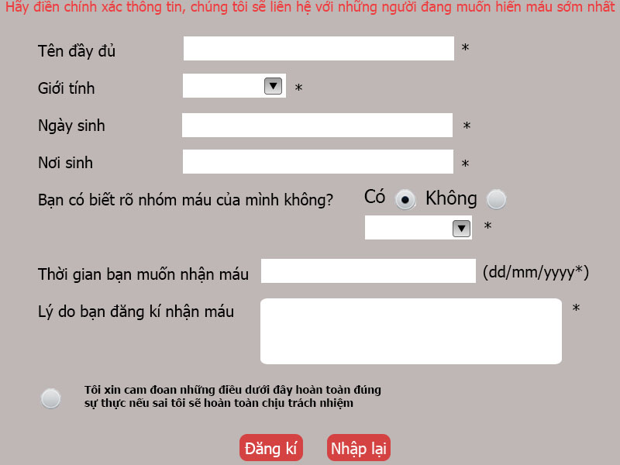

Figure7: Đăng ký nhận máu

|  |  |
| --- | --- |
| Register Receiving Blood | |
| Use case ID | UC015 |
| Use case Name | Register Receiving Blood |
| Primary Actor | Registered User, Admin |
| Description | Registered User/ admin can register receiving blood in the website. |
| Goal | Register receiving blood successful |
| Actions |  |
| Preconditions | User login into the website |
| Main success scenario | |  |  |  | | --- | --- | --- | |  | Actor Input | System Response | | 1 | Click on “Đăng nhập” link. |  | | 2 |  | Display login page | | 3 | Click on “Đăng ký nhận máu” |  | | 4 |  | Display “Đăng ký nhận máu” page | | 5 | Enter necessary and mandatory information and click "Đăng ký" button. |  | | 6 |  | Display message confirm successful. | |
| Post-conditions |  |
| Exceptions | |  |  |  | | --- | --- | --- | |  | Actor Input | System Response | | 1 | Click on “Đăng nhập” link. |  | | 2 |  | Display login page | | 3 | Click on “Đăng ký nhận máu” |  | | 4 |  | Display “Đăng ký nhận máu” page | | 5 | Enter information incorrect or missing mandatory fields & click “Đăng ký” button. |  | | 6 |  | Display error message beside wrong fields. | |
| Author | TamNT01730 |
| Date | 09/26/2013 |

## Create Post

|  |  |
| --- | --- |
| Manage Post: Create Post | |
| Use case ID | UC016 |
| Use case Name | Manage Post: Create Post |
| Primary Actor | Registered User |
| Description | Registered User can Create Post in the website, such as: result of donating/ receiving blood |
| Goal | Create Post successful |
| Actions | Create Post |
| Preconditions | User login into the website |
| Main success scenario | |  |  |  | | --- | --- | --- | |  | Actor Input | System Response | | 1 | Click on “Đăng nhập” link. |  | | 2 |  | Display login page | | 3 | Click on “Chia sẻ” |  | | 4 |  | Display “Chia sẻ” page | | 5 | Enter necessary and mandatory information and click "Gửi" button. |  | | 6 |  | Display message confirm successful. | |
| Post-conditions |  |
| Exceptions | |  |  |  | | --- | --- | --- | |  | Actor Input | System Response | | 1 | Click on “Đăng nhập” link. |  | | 2 |  | Display login page | | 3 | Click on “Chia sẻ” |  | | 4 |  | Display “Chia sẻ” page | | 5 | Enter information incorrect or missing mandatory fields & click “Gửi” button. |  | | 6 |  | Display error message beside wrong fields. | |
| Author | TamNT01730 |
| Date | 10/02/2013 |

## Edit Post

|  |  |
| --- | --- |
| Manage Post: Edit Post | |
| Use case ID | UC017 |
| Use case Name | Manage Post: Edit Post |
| Primary Actor | Registered User |
| Description | User can only edit post that their created when nobody has posted a comment to that post. |
| Goal | Edit Post successful |
| Actions | Edit Post |
| Preconditions | User login into the website |
| Main success scenario | |  |  |  | | --- | --- | --- | |  | Actor Input | System Response | | 1 | Click on “Đăng nhập” link. |  | | 2 |  | Display login page | | 3 | Click on “Chia sẻ” |  | | 4 |  | Display “Chia sẻ” page | | 5 | Open post that you want to edit and click button “Chỉnh sửa” |  | | 6 |  | Display “Chỉnh sửa” page | | 7 | Enter necessary and mandatory information and click "Gửi" button. |  | | 8 |  | Display message confirm successful. | |
| Post-conditions |  |
| Exceptions | |  |  |  | | --- | --- | --- | |  | Actor Input | System Response | | 1 | Click on “Đăng nhập” link. |  | | 2 |  | Display login page | | 3 | Click on “Chia sẻ” |  | | 4 |  | Display “Chia sẻ” page | | 5 | Open post that you want to edit and click button “Chỉnh sửa” |  | | 6 |  | Display “Chỉnh sửa” page | | 7 | Enter information incorrect or missing mandatory fields & click “Gửi” button. |  | | 8 |  | Display error message beside wrong fields. | |
| Author | TamNT01730 |
| Date | 10/02/2013 |

## Delete Post

|  |  |
| --- | --- |
| Manage Post: Delete Post | |
| Use case ID | UC018 |
| Use case Name | Manage Post: Delete Post |
| Primary Actor | Registered User |
| Description | User can only delete post that their created. |
| Goal | Delete Post successful |
| Actions | Delete Post |
| Preconditions | User login into the website |
| Main success scenario | |  |  |  | | --- | --- | --- | |  | Actor Input | System Response | | 1 | Click on “Đăng nhập” link. |  | | 2 |  | Display login page | | 3 | Click on “Chia sẻ” |  | | 4 |  | Display “Chia sẻ” page | | 5 | Open post that you want to delete and click button “Xóa” |  | | 6 |  | Display message confirm successful. | |
| Post-conditions |  |
| Exceptions | |  |  |  | | --- | --- | --- | |  | Actor Input | System Response | |  |  |  | |  |  |  | |
| Author | TamNT01730 |
| Date | 10/02/2013 |

## Contact Us

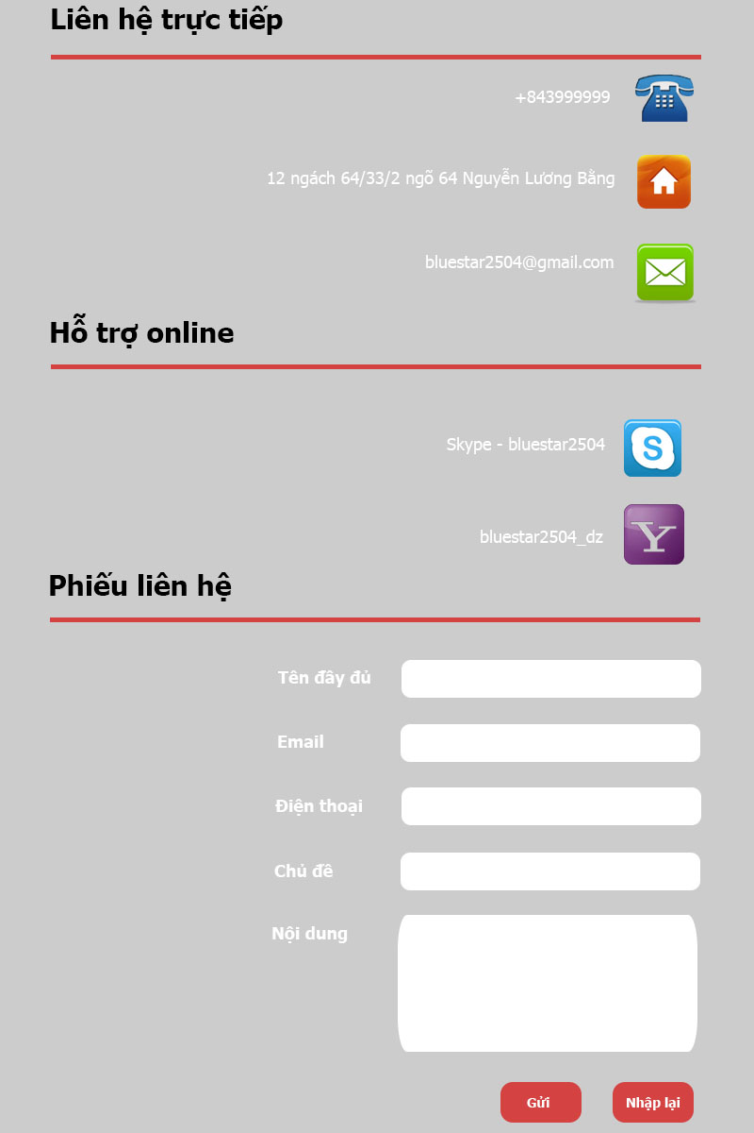

Figure8: Liên hệ

|  |  |
| --- | --- |
| Contact Us | |
| Use case ID | UC019 |
| Use case Name | Contact Us |
| Primary Actor | Registered User |
| Description | User can contact with admin by phone or email. |
| Goal | Contact us successful |
| Actions | Contact with admin |
| Preconditions | User login into the website |
| Main success scenario | |  |  |  | | --- | --- | --- | |  | Actor Input | System Response | | 1 | Click on “Đăng nhập” link. |  | | 2 |  | Display login page | | 3 | Click on “Liên hệ” |  | | 4 |  | Display “Liên hệ” page | | 5 | User can contact with admin by email. User enter correct information and click button “Gửi” |  | | 6 |  | Display message confirm successful. | |
| Post-conditions |  |
| Exceptions | |  |  |  | | --- | --- | --- | |  | Actor Input | System Response | | 1 | Click on “Đăng nhập” link. |  | | 2 |  | Display login page | | 3 | Click on “Liên hệ” |  | | 4 |  | Display “Liên hệ” page | | 5 | User can contact with admin by email. User enter incorrect or missing information and click button “Gửi” |  | | 6 |  | Display error message beside wrong fields. | |
| Author | TamNT01730 |
| Date | 10/01/2013 |

## View Registered User List

|  |  |
| --- | --- |
| Manage Registered User: View Registered User List | |
| Use case ID | UC020 |
| Use case Name | Manage Registered User: View Registered User List |
| Primary Actor | Administrator |
| Description | Administrator can view all information of registered user in the website. |
| Goal | View all information of registered user successful |
| Actions | View Registered User List |
| Preconditions | User login into the website |
| Main success scenario | |  |  |  | | --- | --- | --- | |  | Actor Input | System Response | | 1 | Click on “Đăng nhập” link. |  | | 2 |  | Display login page | | 3 | Click on “Thông tin thành viên” link |  | | 4 |  | Display “Thông tin thành viên” page | | 5 | Select anybody that administrator want to see |  | | 6 |  | Display information successful. | |
| Post-conditions |  |
| Exceptions | |  |  |  | | --- | --- | --- | |  | Actor Input | System Response | |  |  |  | |  |  |  | |
| Author | TamNT01730 |
| Date | 10/02/2013 |

## Delete User

|  |  |
| --- | --- |
| Manage Registered User: Delete User | |
| Use case ID | UC021 |
| Use case Name | Manage Registered User: Delete User |
| Primary Actor | Administrator |
| Description | Administrator can delete user who registered but didn’t use. |
| Goal | Delete registered user |
| Actions | Delete registered user |
| Preconditions | User login into the website |
| Main success scenario | |  |  |  | | --- | --- | --- | |  | Actor Input | System Response | | 1 | Click on “Đăng nhập” link. |  | | 2 |  | Display login page | | 3 | Click on “Thông tin thành viên” link |  | | 4 |  | Display “Thông tin thành viên” page | | 5 | Select anybody and click “Xóa ”button |  | | 6 |  | Delete registered user successful. | |
| Post-conditions |  |
| Exceptions | |  |  |  | | --- | --- | --- | |  | Actor Input | System Response | |  |  |  | |  |  |  | |
| Author | TamNT01730 |
| Date | 10/02/2013 |

## Ban User

|  |  |
| --- | --- |
| Manage Registered User: Ban User | |
| Use case ID | UC022 |
| Use case Name | Manage Registered User: Ban User |
| Primary Actor | Administrator |
| Description | Administrator can ban user who violated rule of website. |
| Goal | Ban user |
| Actions |  |
| Preconditions | User login into the website |
| Main success scenario | |  |  |  | | --- | --- | --- | |  | Actor Input | System Response | | 1 | Click on “Đăng nhập” link. |  | | 2 |  | Display login page | | 3 | Click on “Thông tin thành viên” link |  | | 4 |  | Display “Thông tin thành viên” page | | 5 | Select anybody and click “Cấm” button |  | | 6 |  | Ban user successful. | |
| Post-conditions |  |
| Exceptions | |  |  |  | | --- | --- | --- | |  | Actor Input | System Response | |  |  |  | |  |  |  | |
| Author | TamNT01730 |
| Date | 10/02/2013 |

## Unban User

|  |  |
| --- | --- |
| Manage Registered User: Unban User | |
| Use case ID | UC023 |
| Use case Name | Manage Registered User: Unban User |
| Primary Actor | Administrator |
| Description | Administrator can unban user who is ban user after 7 days. |
| Goal | Unban user |
| Actions |  |
| Preconditions | User login into the website |
| Main success scenario | |  |  |  | | --- | --- | --- | |  | Actor Input | System Response | | 1 | Click on “Đăng nhập” link. |  | | 2 |  | Display login page | | 3 | Click on “Thông tin thành viên” link |  | | 4 |  | Display “Thông tin thành viên” page | | 5 | Select anybody and click “Cho phép” button |  | | 6 |  | Unban user successful. | |
| Post-conditions |  |
| Exceptions | |  |  |  | | --- | --- | --- | |  | Actor Input | System Response | |  |  |  | |  |  |  | |
| Author | TamNT01730 |
| Date | 10/02/2013 |

## Delete User

|  |  |
| --- | --- |
| Manage Posts: Delete Post | |
| Use case ID | UC024 |
| Use case Name | Manage Posts: Delete Post |
| Primary Actor | Administrator |
| Description | Administrator can delete all post that too old or violated rule of website. |
| Goal | Delete Post successful |
| Actions |  |
| Preconditions | User login into the website |
| Main success scenario | |  |  |  | | --- | --- | --- | |  | Actor Input | System Response | | 1 | Click on “Đăng nhập” link. |  | | 2 |  | Display login page | | 3 | Click on “Quản lý bài đăng” link |  | | 4 |  | Display “Quản lý bài đăng” page | | 5 | Select post and click “Xóa” button |  | | 6 |  | Delete post successful. | |
| Post-conditions |  |
| Exceptions | |  |  |  | | --- | --- | --- | |  | Actor Input | System Response | |  |  |  | |  |  |  | |
| Author | TamNT01730 |
| Date | 10/02/2013 |

## View Post

|  |  |
| --- | --- |
| Manage Posts: View Post | |
| Use case ID | UC025 |
| Use case Name | Manage Posts: View Post |
| Primary Actor | Administrator |
| Description | Administrator can view all post of website. |
| Goal | View Post successful |
| Actions |  |
| Preconditions | User login into the website |
| Main success scenario | |  |  |  | | --- | --- | --- | |  | Actor Input | System Response | | 1 | Click on “Đăng nhập” link. |  | | 2 |  | Display login page | | 3 | Click on “Quản lý bài đăng” link |  | | 4 |  | Display “Quản lý bài đăng” page | | 5 | Select post that you want to see and click “Xem”button. |  | | 6 |  | Display post | |
| Post-conditions |  |
| Exceptions | |  |  |  | | --- | --- | --- | |  | Actor Input | System Response | |  |  |  | |  |  |  | |
| Author | TamNT01730 |
| Date | 10/02/2013 |

## Create Post

|  |  |
| --- | --- |
| Manage Posts: Create Post | |
| Use case ID | UC026 |
| Use case Name | Manage Posts: Create Post |
| Primary Actor | Administrator |
| Description | Administrator can create post of website. |
| Goal | View Post successful |
| Actions |  |
| Preconditions | User login into the website |
| Main success scenario | |  |  |  | | --- | --- | --- | |  | Actor Input | System Response | | 1 | Click on “Đăng nhập” link. |  | | 2 |  | Display login page | | 3 | Click on “Quản lý bài đăng” link |  | | 4 |  | Display “Quản lý bài đăng” page | | 5 | Create new post |  | | 6 |  | Display post in the website | |
| Post-conditions |  |
| Exceptions | |  |  |  | | --- | --- | --- | |  | Actor Input | System Response | |  |  |  | |  |  |  | |
| Author | TamNT01730 |
| Date | 10/02/2013 |

## Edit Post

|  |  |
| --- | --- |
| Manage Posts: Edit Post | |
| Use case ID | UC027 |
| Use case Name | Manage Posts: Edit Post |
| Primary Actor | Administrator |
| Description | Administrator can edit post that their posted in the website. |
| Goal | Edit Post successful |
| Actions |  |
| Preconditions | User login into the website |
| Main success scenario | |  |  |  | | --- | --- | --- | |  | Actor Input | System Response | | 1 | Click on “Đăng nhập” link. |  | | 2 |  | Display login page | | 3 | Click on “Quản lý bài đăng” link |  | | 4 |  | Display “Quản lý bài đăng” page | | 5 | Select post that they want to edit and click “Sửa” button |  | | 6 |  | Display post with new information in the website | |
| Post-conditions |  |
| Exceptions | |  |  |  | | --- | --- | --- | |  | Actor Input | System Response | |  |  |  | |  |  |  | |
| Author | TamNT01730 |
| Date | 10/02/2013 |

## View Comment List

|  |  |
| --- | --- |
| Manage Comments: View Comment List | |
| Use case ID | UC028 |
| Use case Name | Manage Comments: View Comment List |
| Primary Actor | Administrator |
| Description | Administrator can view comment list of all registered user in the website. |
| Goal | View comment list successful |
| Actions |  |
| Preconditions | User login into the website |
| Main success scenario | |  |  |  | | --- | --- | --- | |  | Actor Input | System Response | | 1 | Click on “Đăng nhập” link. |  | | 2 |  | Display login page | | 3 | Click on “Quản lý comment” link |  | | 4 |  | Display “Quản lý comment” page | | 5 | Select comment that they want to see and click “Xem” button |  | | 6 |  | Display comment | |
| Post-conditions |  |
| Exceptions | |  |  |  | | --- | --- | --- | |  | Actor Input | System Response | |  |  |  | |  |  |  | |
| Author | TamNT01730 |
| Date | 10/02/2013 |

## Delete Comment

|  |  |
| --- | --- |
| Manage Comments: Delete Comment | |
| Use case ID | UC029 |
| Use case Name | Manage Comments: Delete Comment |
| Primary Actor | Administrator |
| Description | Administrator can delete comment that violated rule of website. |
| Goal | Delete comment list successful |
| Actions |  |
| Preconditions | User login into the website |
| Main success scenario | |  |  |  | | --- | --- | --- | |  | Actor Input | System Response | | 1 | Click on “Đăng nhập” link. |  | | 2 |  | Display login page | | 3 | Click on “Quản lý comment” link |  | | 4 |  | Display “Quản lý comment” page | | 5 | Select comment that they want to delete and click “Xóa” button |  | | 6 |  | Delete comment | |
| Post-conditions |  |
| Exceptions | |  |  |  | | --- | --- | --- | |  | Actor Input | System Response | |  |  |  | |  |  |  | |
| Author | TamNT01730 |
| Date | 10/02/2013 |

## View Q&A List

|  |  |
| --- | --- |
| Manage Q&A: View Q&A List | |
| Use case ID | UC030 |
| Use case Name | Manage Q&A: View Q&A List |
| Primary Actor | Administrator |
| Description | Administrator can view Q&A list of all registered user in the website. |
| Goal | View Q&A list successful |
| Actions |  |
| Preconditions | User login into the website |
| Main success scenario | |  |  |  | | --- | --- | --- | |  | Actor Input | System Response | | 1 | Click on “Đăng nhập” link. |  | | 2 |  | Display login page | | 3 | Click on “Quản lý Q&A” link |  | | 4 |  | Display “Quản lý Q&A” page | | 5 | Select Q&A that they want to see and click “Xem” button |  | | 6 |  | Display Q&A | |
| Post-conditions |  |
| Exceptions | |  |  |  | | --- | --- | --- | |  | Actor Input | System Response | |  |  |  | |  |  |  | |
| Author | TamNT01730 |
| Date | 10/02/2013 |

## Delete Q&A

|  |  |
| --- | --- |
| Manage Q&A: Delete Q&A | |
| Use case ID | UC031 |
| Use case Name | Manage Q&A: Delete Q&A |
| Primary Actor | Administrator |
| Description | Administrator can delete Q&A that too old or violated rule of website. |
| Goal | Delete Q&A successful |
| Actions |  |
| Preconditions | User login into the website |
| Main success scenario | |  |  |  | | --- | --- | --- | |  | Actor Input | System Response | | 1 | Click on “Đăng nhập” link. |  | | 2 |  | Display login page | | 3 | Click on “Quản lý Q&A” link |  | | 4 |  | Display “Quản lý Q&A” page | | 5 | Select Q&A that they want to delete and click “Xóa” button |  | | 6 |  | Delete Q&A | |
| Post-conditions |  |
| Exceptions | |  |  |  | | --- | --- | --- | |  | Actor Input | System Response | |  |  |  | |  |  |  | |
| Author | TamNT01730 |
| Date | 10/02/2013 |

## View History Donating Blood

|  |  |
| --- | --- |
| View History Donating Blood | |
| Use case ID | UC032 |
| Use case Name | View History Donating Blood |
| Primary Actor | Registered user |
| Description | Registered user can view history donating blood within a week, a month, a year. |
| Goal | View history donating blood successful |
| Actions |  |
| Preconditions | User login into the website |
| Main success scenario | |  |  |  | | --- | --- | --- | |  | Actor Input | System Response | | 1 | Click on “Đăng nhập” link. |  | | 2 |  | Display login page | | 3 | Click on “Lịch sử hiến máu” link |  | | 4 |  | Display “Lịch sử hiến máu” page. This page displays all information register donating blood of all users. | |
| Post-conditions |  |
| Exceptions | |  |  |  | | --- | --- | --- | |  | Actor Input | System Response | |  |  |  | |  |  |  | |
| Author | TamNT01730 |
| Date | 10/16/2013 |

## View History Receiving Blood

|  |  |
| --- | --- |
| View History Receiving Blood | |
| Use case ID | UC033 |
| Use case Name | View History Receiving Blood |
| Primary Actor | Registered user |
| Description | Registered user can view history receiving blood within a week, a month, a year. |
| Goal | View history receiving blood successful |
| Actions |  |
| Preconditions | User login into the website |
| Main success scenario | |  |  |  | | --- | --- | --- | |  | Actor Input | System Response | | 1 | Click on “Đăng nhập” link. |  | | 2 |  | Display login page | | 3 | Click on “Lịch sử nhận máu” link |  | | 4 |  | Display “Lịch sử nhận máu” page. This page displays all information register receiving blood of all users. | |
| Post-conditions |  |
| Exceptions | |  |  |  | | --- | --- | --- | |  | Actor Input | System Response | |  |  |  | |  |  |  | |
| Author | TamNT01730 |
| Date | 10/16/2013 |

## Count Actions Donating Blood

|  |  |
| --- | --- |
| Count Actions Donating Blood | |
| Use case ID | UC034 |
| Use case Name | Count Actions Donating Blood |
| Primary Actor | Administrator |
| Description | Administrator can count actions donating blood within a week, a moth, a year. |
| Goal | Count actions donating blood successful |
| Actions |  |
| Preconditions | User login into the website |
| Main success scenario | |  |  |  | | --- | --- | --- | |  | Actor Input | System Response | | 1 | Click on “Đăng nhập” link. |  | | 2 |  | Display login page | | 3 | Click on “Lịch sử hiến máu” link |  | | 4 |  | Display “Lịch sử hiến máu” page. This page displays all information register donating blood of all users. | | 5 | Select range register donating blood that you want: a week, a month, a year. |  | | 6 |  | Display information corresponding to the range that you search. | |
| Post-conditions |  |
| Exceptions | |  |  |  | | --- | --- | --- | |  | Actor Input | System Response | |  |  |  | |  |  |  | |
| Author | TamNT01730 |
| Date | 10/16/2013 |

## Count Actions Receiving Blood

|  |  |
| --- | --- |
| Count Actions Receiving Blood | |
| Use case ID | UC035 |
| Use case Name | Count Actions Receiving Blood |
| Primary Actor | Administrator |
| Description | Administrator can count actions receiving blood within a week, a month, a year. |
| Goal | Count actions receiving blood successful |
| Actions |  |
| Preconditions | User login into the website |
| Main success scenario | |  |  |  | | --- | --- | --- | |  | Actor Input | System Response | | 1 | Click on “Đăng nhập” link. |  | | 2 |  | Display login page | | 3 | Click on “Lịch sử nhận máu” link |  | | 4 |  | Display “Lịch sử nhận máu” page. This page displays all information register receiving blood of all users. | | 5 | Select range register receiving blood that you want: a week, a month, a year. |  | | 6 |  | Display information corresponding to the range that you search. | |
| Post-conditions |  |
| Exceptions | |  |  |  | | --- | --- | --- | |  | Actor Input | System Response | |  |  |  | |  |  |  | |
| Author | TamNT01730 |
| Date | 10/16/2013 |

## Usability

* The website interface is clear, simple and out-standing.
* All of post and the input of website will be validated.
* The user should only have general computer use knowledge. Error messages will be displayed in case of an invalid request. Users need no time for training or reading guideline.
* User can receive supports from admin (or volunteer of website) via hotline of website.

## Reliability

* The information in the home page is useful because we has been reviewed, controlled, or referred to reliable sources.
* The database must be backed up regularly and can be recovered if necessary.

## Performance

None

## Supportability

None

## Design Constraints

None

## On-line User Documentation and Help System Requirements

None

## Purchased Components

None

## Interfaces

None

## Licensing Requirements

None

## Legal, Copyright, and Other Notices

None

## Applicable Standards

None

# Supporting Information

There are some supporting information makes the SRS easier to use. It includes:

* Table of contents
* Index
* Appendices